Abstract :
This project presents a dynamic personal portfolio website developed to showcase the academic details, technical skills, projects, achievements, internship experience, and contact information of a Computer Science and Engineering student. The website is designed using HTML for webpage structure, CSS for styling and responsive design, and JavaScript for client-side interactivity. PHP is used for server-side processing, while MySQL is used to store contact form details. The system provides a user-friendly interface where visitors can view the student's profile and submit messages through the contact form. The submitted information is processed using PHP and stored securely in the MySQL database. The project demonstrates the integration of front-end technologies with server-side programming and database connectivity to develop a functional and dynamic web application.
Introduction :
A personal portfolio website is a web-based application used to present a student's academic background, technical skills, projects, achievements, internship experience, and contact information in an organized manner. It provides a professional online presence and allows visitors to easily understand the student's educational and technical profile.
This project focuses on developing a dynamic personal portfolio website using modern web technologies. HTML is used to create the structure of the website, CSS is used for styling and responsive design, and JavaScript is used to provide interactive features. PHP is used for server-side processing, while MySQL is used to store contact form information.
The website contains different sections such as Home, About, Academic Details, Skills, Projects, Achievements, Internships, and Contact. The contact section allows visitors to submit their details and messages. These details are processed using PHP and stored in the MySQL database through XAMPP.
The main objective of this project is to demonstrate the practical implementation of front-end development, server-side programming, form handling, and database connectivity in Internet Programming. The project provides a simple, user-friendly, and functional platform for presenting personal and professional information online.
Methodology / Approach:
The development of the personal portfolio website is carried out using a combination of front-end and back-end web technologies. The methodology focuses on designing a user-friendly interface, implementing interactive features, processing user input, and storing contact information in a database.
1. Requirement Analysis
The requirements of the portfolio website are identified first. The website should display personal information, academic details, technical skills, projects, achievements, internship experience, and contact details.
2. Front-End Development
HTML is used to create the basic structure and different sections of the portfolio. CSS is used to design the webpage, including layouts, fonts, colors, buttons, and responsive elements. JavaScript is used to add client-side interaction and improve the user experience.

3. Back-End Development
PHP is used for server-side processing. The contact form data entered by the visitor is received and processed by the PHP program. The submitted information is then prepared for storage in the database.
4. Database Connectivity
MySQL is used to store the contact form details. XAMPP provides the Apache web server and MySQL database environment. PHP connects the website with the MySQL database and inserts the submitted contact information into the appropriate table.
5. Testing
The website is tested by checking all navigation links, webpage sections, contact form fields, database connectivity, and form submission. The stored contact details are verified using phpMyAdmin.
6. Deployment
After successful testing, the project can be uploaded to a suitable hosting platform. The GitHub repository is used to maintain and share the project source code, while the hosted website provides access to the completed portfolio.
Implementation Code:
1. index.php
<!DOCTYPE html>
<html>
<head>
<title>My Personal Portfolio</title>
<link rel="stylesheet" href="style.css">
</head>
<body>
<header>
<h1>Vignesh Kumar R</h1>
<p>Computer Science and Engineering Student</p>
</header>
<nav>
<a href="#home">Home</a>
<a href="#about">About</a>
<a href="#skills">Skills</a>
<a href="#projects">Projects</a>
<a href="#contact">Contact</a>
</nav>
<section id="home">
<h2>Welcome to My Portfolio</h2>
<p>I am a Computer Science and Engineering student interested in
programming, software development and technology.</p>
</section>
<section id="about">
<h2>About Me</h2>
<p>I am pursuing B.E. Computer Science and Engineering at
Kamaraj College of Engineering and Technology.</p>
</section>
<section id="skills">
<h2>Technical Skills</h2>
<ul>
<li>C</li>
<li>Python</li>
<li>HTML & CSS</li>
<li>JavaScript</li>
<li>Java</li>
<li>MySQL</li>
</ul>
</section>
<section id="projects">
<h2>Projects</h2>
<ul>
<li>SafeVia – AI-Assisted Crime-Aware Safe Route Navigation</li>
<li>Smart Irrigation System using IoT</li>
<li>E-Learning Website</li>
<li>Online Cars Website</li>
</ul>
</section>
<section id="contact">
<h2>Contact Me</h2>
<form action="contact.php" method="POST">
<input type="text" name="name"
placeholder="Your Name" required>
<input type="email" name="email"
placeholder="Your Email" required>
<input type="text" name="subject"
placeholder="Subject" required>
<textarea name="message"
placeholder="Your Message" required></textarea>
<button type="submit">Send Message</button>
</form>
</section>
<script src="script.js"></script>
</body>
</html>
2. style.css
* {
margin: 0;
padding: 0;
box-sizing: border-box;
}
body {
font-family: Arial, sans-serif;
line-height: 1.6;
background: #f4f4f4;
color: #333;
}
header {
text-align: center;
padding: 40px;
background: #222;
color: white;
}
nav {
text-align: center;
padding: 15px;
background: #333;
}
nav a {
color: white;
text-decoration: none;
margin: 15px;
}
section {
padding: 40px;
max-width: 900px;
margin: auto;
}
h2 {
margin-bottom: 15px;
}
input,
textarea {
width: 100%;
padding: 12px;
margin: 8px 0;
}
textarea {
height: 120px;
}

button {
padding: 12px 25px;
border: none;
cursor: pointer;
}
3. script.js
document.addEventListener("DOMContentLoaded", function () {
console.log("Portfolio website loaded successfully.");
});
4. db.php
<?php
$host = "localhost";
$user = "root";
$password = "";
$database = "portfolio_db";
$conn = new mysqli($host, $user, $password, $database);
if ($conn->connect_error) {
die("Database connection failed: " . $conn->connect_error);
}
?>
5. contact.php
<?php
include 'db.php';
if ($_SERVER["REQUEST_METHOD"] == "POST") {
$name = $_POST["name"];
$email = $_POST["email"];
$subject = $_POST["subject"];
$message = $_POST["message"];
$sql = "INSERT INTO contacts
(name, email, subject, message)
VALUES (?, ?, ?, ?)";
$stmt = $conn->prepare($sql);
$stmt->bind_param("ssss",
$name,
$email,
$subject,
$message
);
if ($stmt->execute()) {
echo "<script>
alert('Message sent successfully!');
window.location.href='index.php#contact';
</script>";
} else {
echo "Error while submitting the message.";
}

$stmt->close();
$conn->close();
}
?>
6. MySQL Database
CREATE DATABASE portfolio_db;
USE portfolio_db;
CREATE TABLE contacts (
id INT AUTO_INCREMENT PRIMARY KEY,
name VARCHAR(100) NOT NULL,
email VARCHAR(100) NOT NULL,
subject VARCHAR(150),
message TEXT NOT NULL,
created_at TIMESTAMP DEFAULT CURRENT_TIMESTAMP
);
Screen Shot:
Home page:
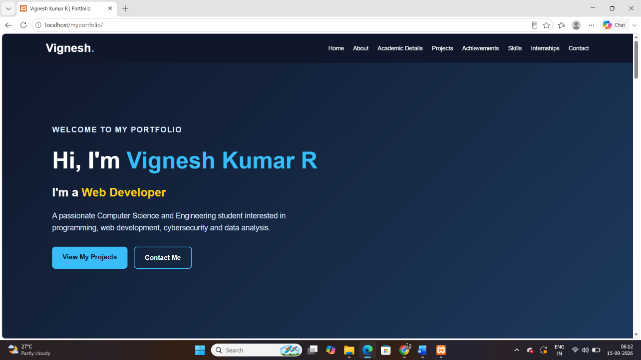

About me:
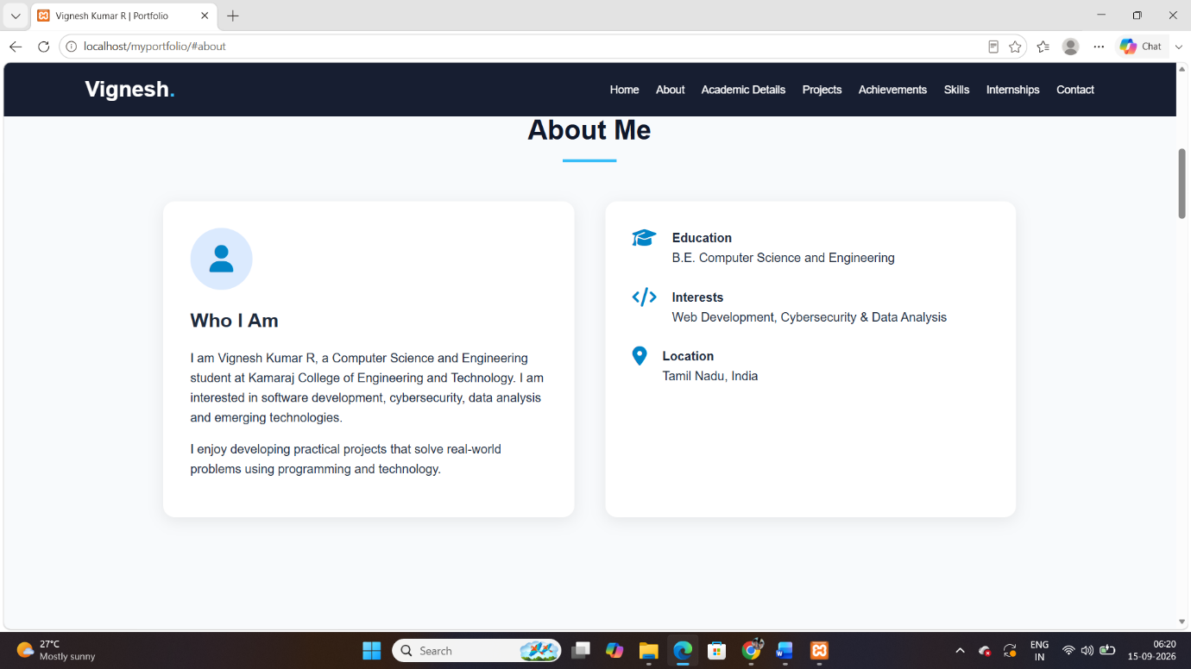
Skills:
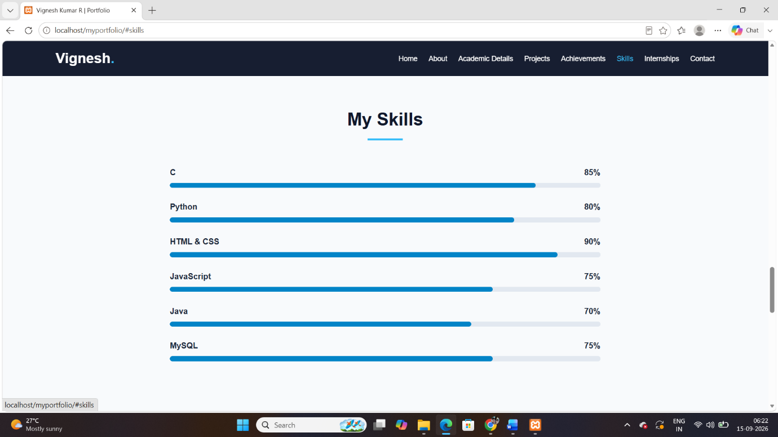

Project: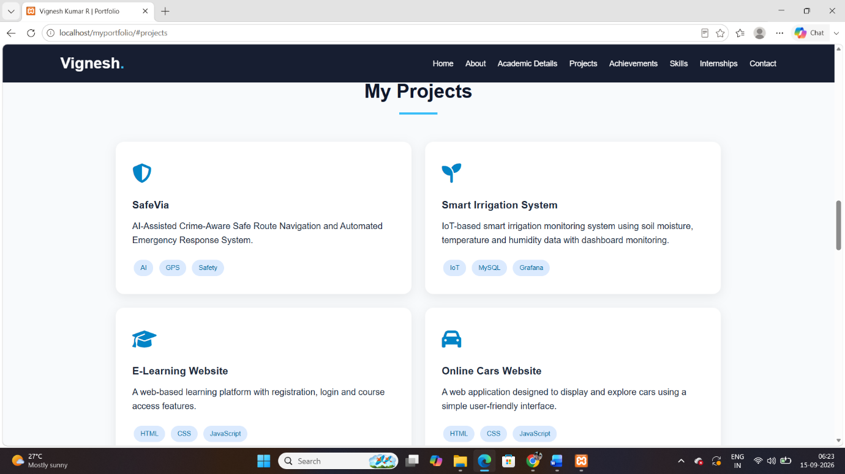

Contact me:
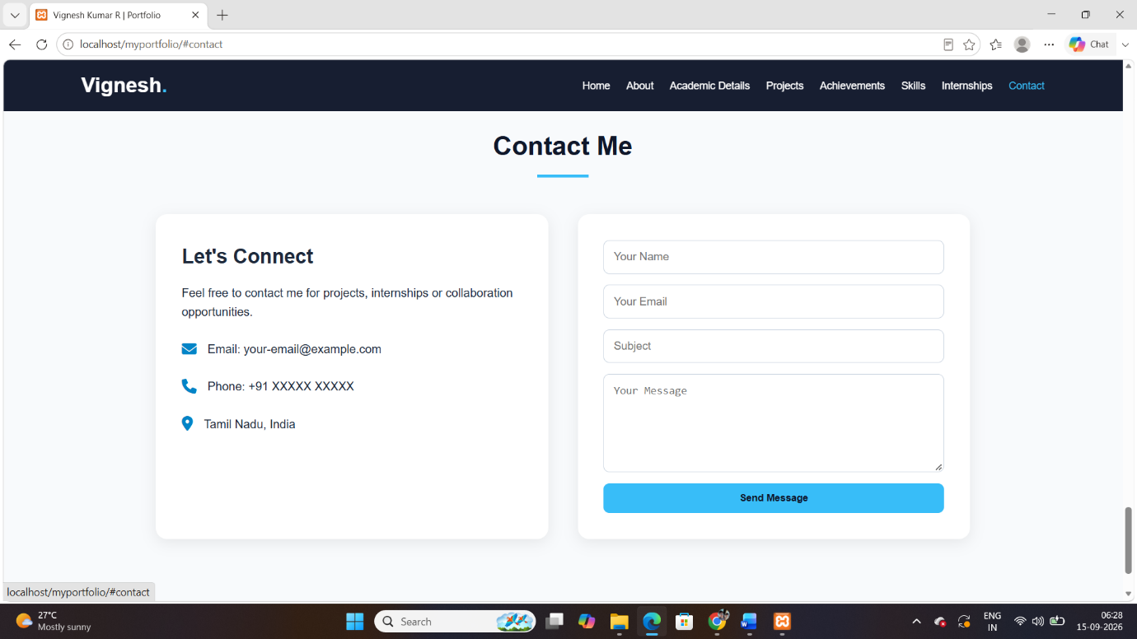

Achivement:
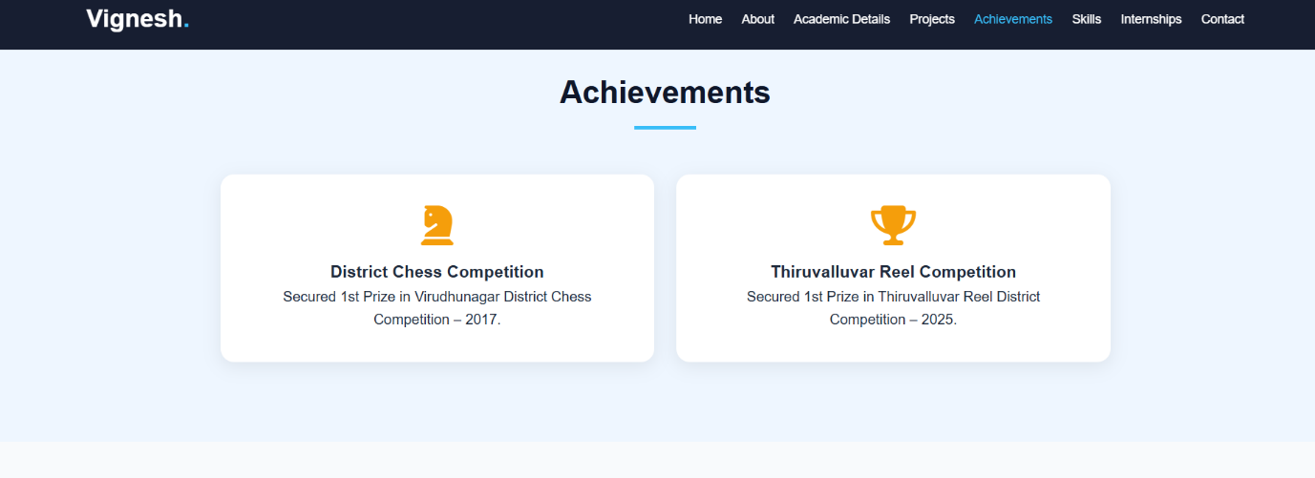
Internship:
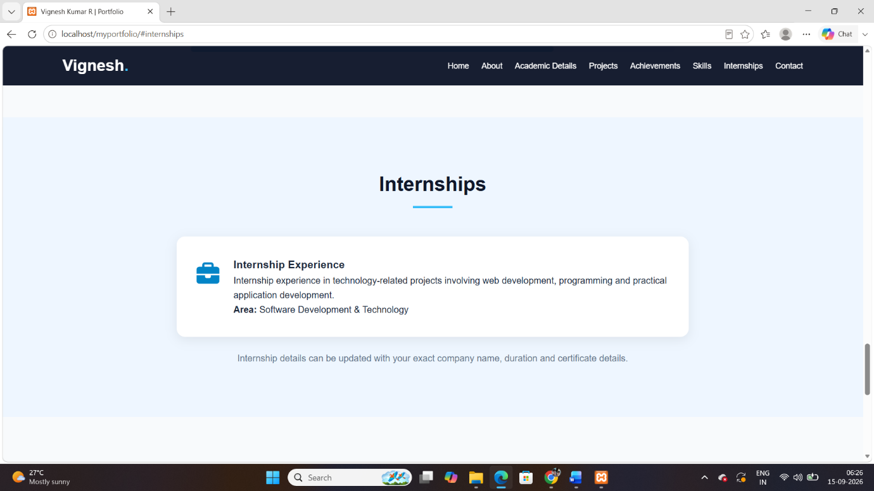

Successful Submission:



MySQL Database:
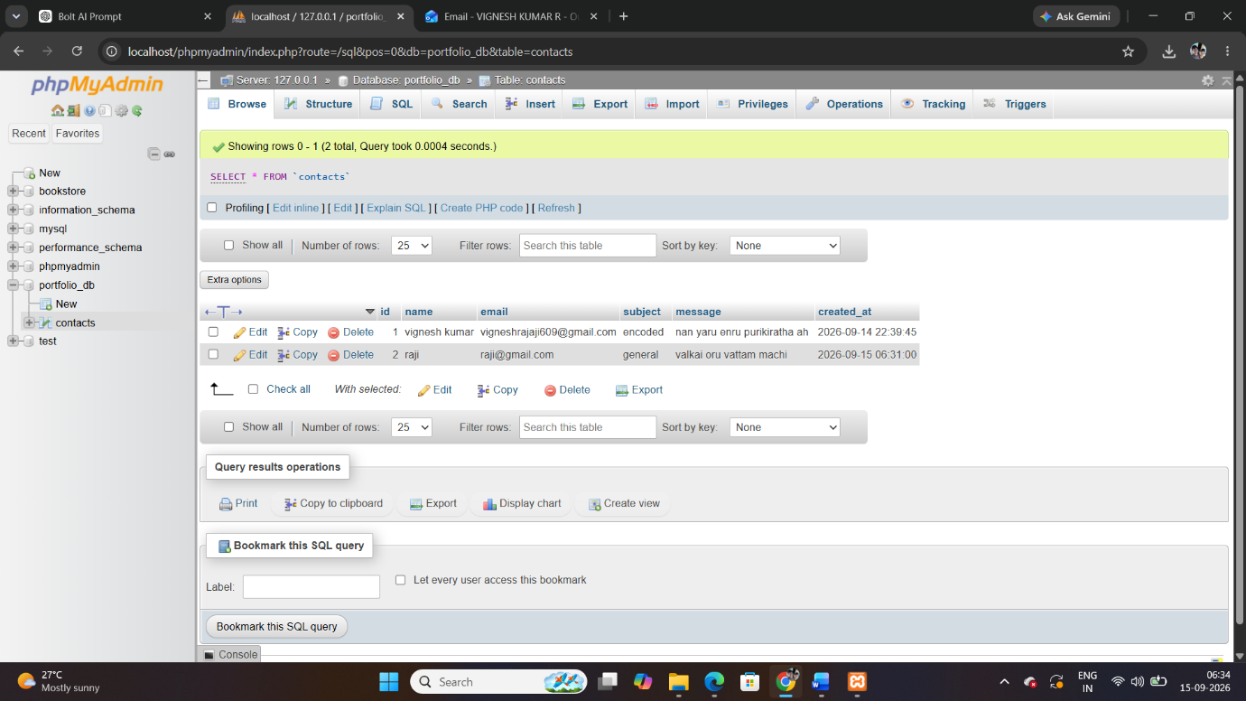

XAMPP:
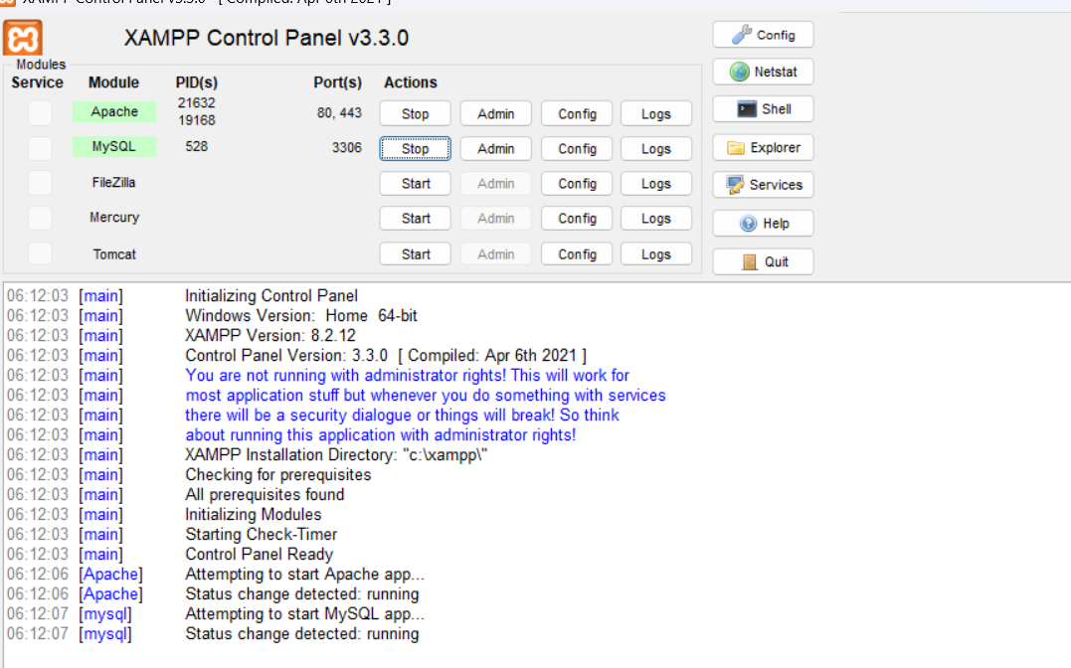

Conclusion
The personal portfolio website was successfully developed using HTML, CSS, JavaScript, PHP, and MySQL. The website provides an organized platform to display the student's personal details, academic information, technical skills, projects, achievements, internship experience, and contact information.
HTML and CSS were used to create and design the webpage, while JavaScript was used to provide basic interactivity. PHP was implemented for server-side processing and contact form handling. MySQL was used to store the details submitted through the contact form, demonstrating database connectivity using XAMPP and phpMyAdmin.
This project provides practical experience in front-end development, back-end programming, form processing, and database management. Overall, the project successfully demonstrates the integration of different Internet Programming technologies to create a simple, functional, and user-friendly dynamic web application.

